Mathematics Specialist Investigations

Year 12

Topic 2: Functions and sketching graphs

Authors: Rom Cirillo
Margaret Denham
Romaine Saunders
Amy Shaw
Ed Taylor

Editors: Rom Cirillo
Romaine Saunders

For each topic three types of tasks are included:
- Extended investigation – an investigation which could be done in the student’s own time followed by an in-class validation. Solutions are provided where practicable for the preparation activity/investigation. For the in-class validation, there are solutions and marking keys which identify the mathematical behaviours that students may exhibit.
- In-class investigation – an investigation for which no prior preparation is required. Solutions and marking keys are provided.
- Investigative questions – a series of short questions which test the student’s ability to apply their learning, to justify their conclusions, to investigate and to generalise, or to solve problems. Such questions could be included in a response or examination assessment. Solutions and marking key are provided.

Screen shot have been produced using the CASIO ClassPad II emulator or the ti-nspire CAS emulator.

Most graphs and diagrams have been produced using efofex software.

© The investigations and solutions in this publication are for the sole use of staff and students of the purchasing school. It is a breach of copyright to distribute them in whole or part in any form now or in the future to any other school, company or person.

Contents:
MATHEMATICS SPECIALIST: Year 12

3.1 Complex numbers
Task 1: Extended investigation: The Factor and Remainder Theorems
Task 2: In-class investigation: Complex numbers using e^{iθ}
Task 3: Investigative questions

3.2 Functions and sketching graphs
Task 4: Extended investigation: The graphs of rational functions
Task 5: In-class investigation: The absolute value function
Task 6: Investigative questions

3.3 Vectors in three dimensions
Task7: Extended investigation: Systems of equations
Task 8: In-class investigation: Cross product
Task 9: Investigative questions

4.1 Integration and applications of integration
Task10: Extended investigation: The Golden Gate bridge
Task 11: In-class investigation: Which sculpture
Task 12: Investigative questions

4.2 Rates of change and differential equations
Task13: Extended investigation: Time of death
Task 14: In-class investigation: The logistic function
Task 15: Investigative questions

4.3 Statistical inference
Task16: Extended investigation: TBA
Task 17: In-class investigation: TBA
Task 18: Investigative questions

This package only contains the investigations associated with topic 3.2: Functions and sketching graphs

If your school has purchased the complete set of 18 investigations, you will be informed when the rest are ready for delivery/download, which will be sometime later in Term 1.

TASK 4

THE GRAPHS OF RATIONAL FUNCTIONS

Extended Investigation

Unit 3.2

Topic: Functions and Sketching Graphs

Course-related information

The concepts and skills included in this investigation relate to the following dot points within the WA Mathematics Specialist syllabus.
3.2.8 sketch the graphs of simple rational functions where the numerator and denominator are polynomials of low degree

Background information

It is assumed that students are familiar with Methods 1.1.14 (reciprocal functions).

Task conditions

The preparation activity assumes that students will have access to CAS calculators. Students are expected to complete the preparation activity before the in-class validation. Students should not be permitted to take their investigative material into the in-class assessment. Students should not use their calculators for the in-class validation.

The graphs of rational functions

Extended investigation Part 1: Preparation activity

A rational function is of the form where are polynomials.
is a proper rational function if the degree of the polynomial is less than the degree of the polynomial .
For example, are proper rational functions whilst are improper rational functions.

To determine the behavior as of a proper fraction, divide the numerator and denominator of the fraction by the highest power of that occurs in the denominator and then consider the value of the resulting expression as .
For example, consider .
The highest power of in the denominator is 3; hence, divide numerator and denominator by giving .
As , i.e. .
Hence, the graph of has a horizontal asymptote with equation .
As .
As .
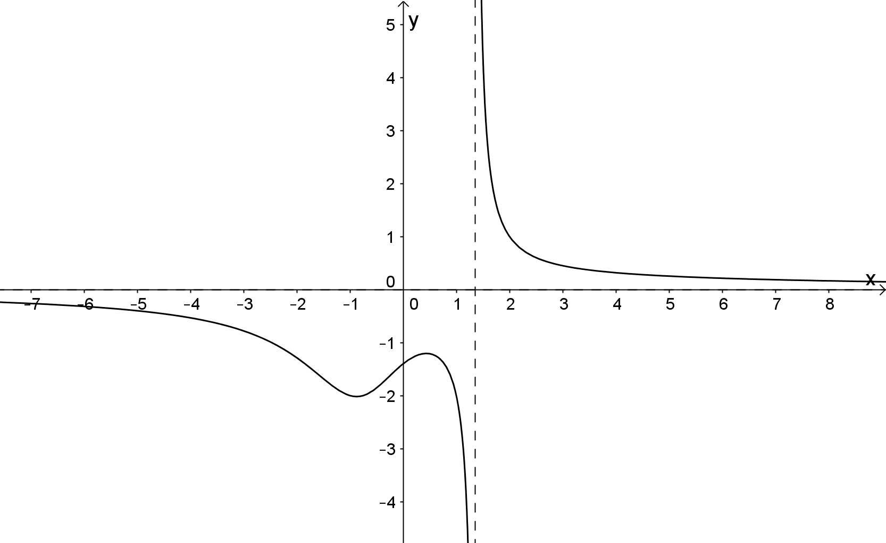

To determine the behaviour as of an improper fraction, first rewrite the numerator in terms of the denominator and then simplify.
For example, consider
As . The graph of has a horizontal asymptote with equation .
As .
As .
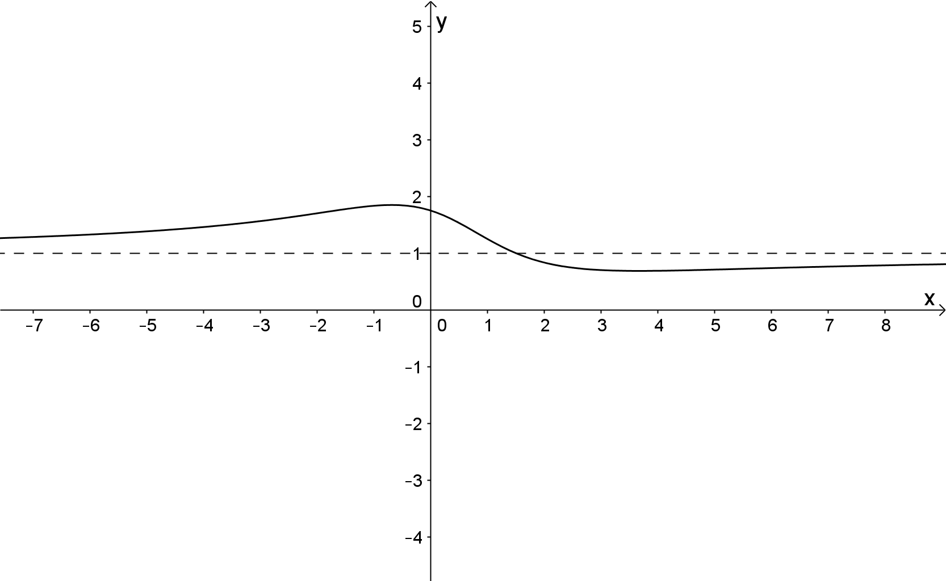
Investigate the graphs of the rational function .
Consider
(a)
Hint : Consider the different relative positions of on the axis.
Also, consider .
(b) where has no real roots.
(c) where has no real roots.
(d) where neither nor have real roots.
(e)
Note:
- Sketches should be clearly labelled and should clearly show the features of the graph, including intercepts and horizontal and/or vertical asymptotes.
- The exact location of any turning points does not need to be found.

The graphs of rational functions

Extended investigation Part 2: In-class validation (40 marks)

Question 1 (10 marks)
Consider the graph of the function .
(a) Determine any vertical asymptotes. (1)

(b) Determine any intercepts. (2)

(c) Determine the behaviour of the graph as and hence identify the horizontal asymptote. (2)

(d) Determine the coordinates of any point(s) at which the graph intersects the horizontal asymptote. (2)

(e) Sketch the function. (3)

Question 2 (6 marks)
Sketch the graph of showing clearly any asymptotes and intercepts.

Question 3 (6 marks)

Consider the rational function .
(a) Express in the form where is a proper rational fraction and .
(3)

(b) What is the behaviour of as ? (1)

The behaviour of as determines the equation of the oblique asymptote.
(c) Write down the equation of the oblique asymptote. (2)

Question 4 (9 marks)

Sketch the graph of showing clearly any vertical and oblique asymptotes and intercepts.

Question 5 (9 marks)

The graph of is shown below.

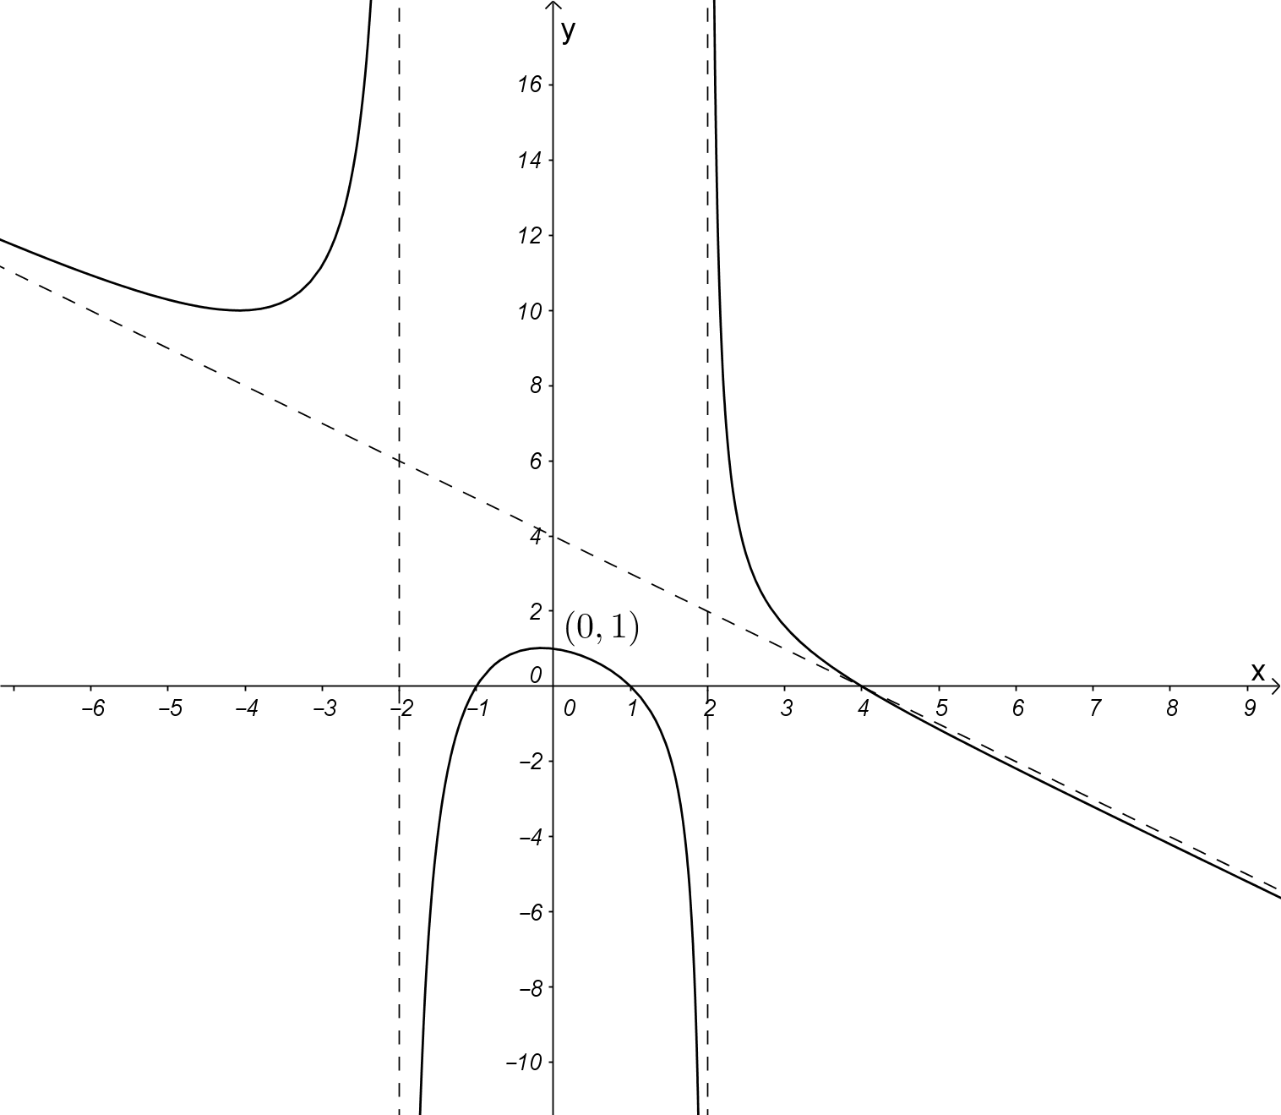

Determine:
(a) the equation of the oblique asymptote, (1)

(b) the values of the constants . (8)

The graphs of rational functions

Extended investigation Part 1: Preparation activity
Solutions

(a)
Solution
For example,
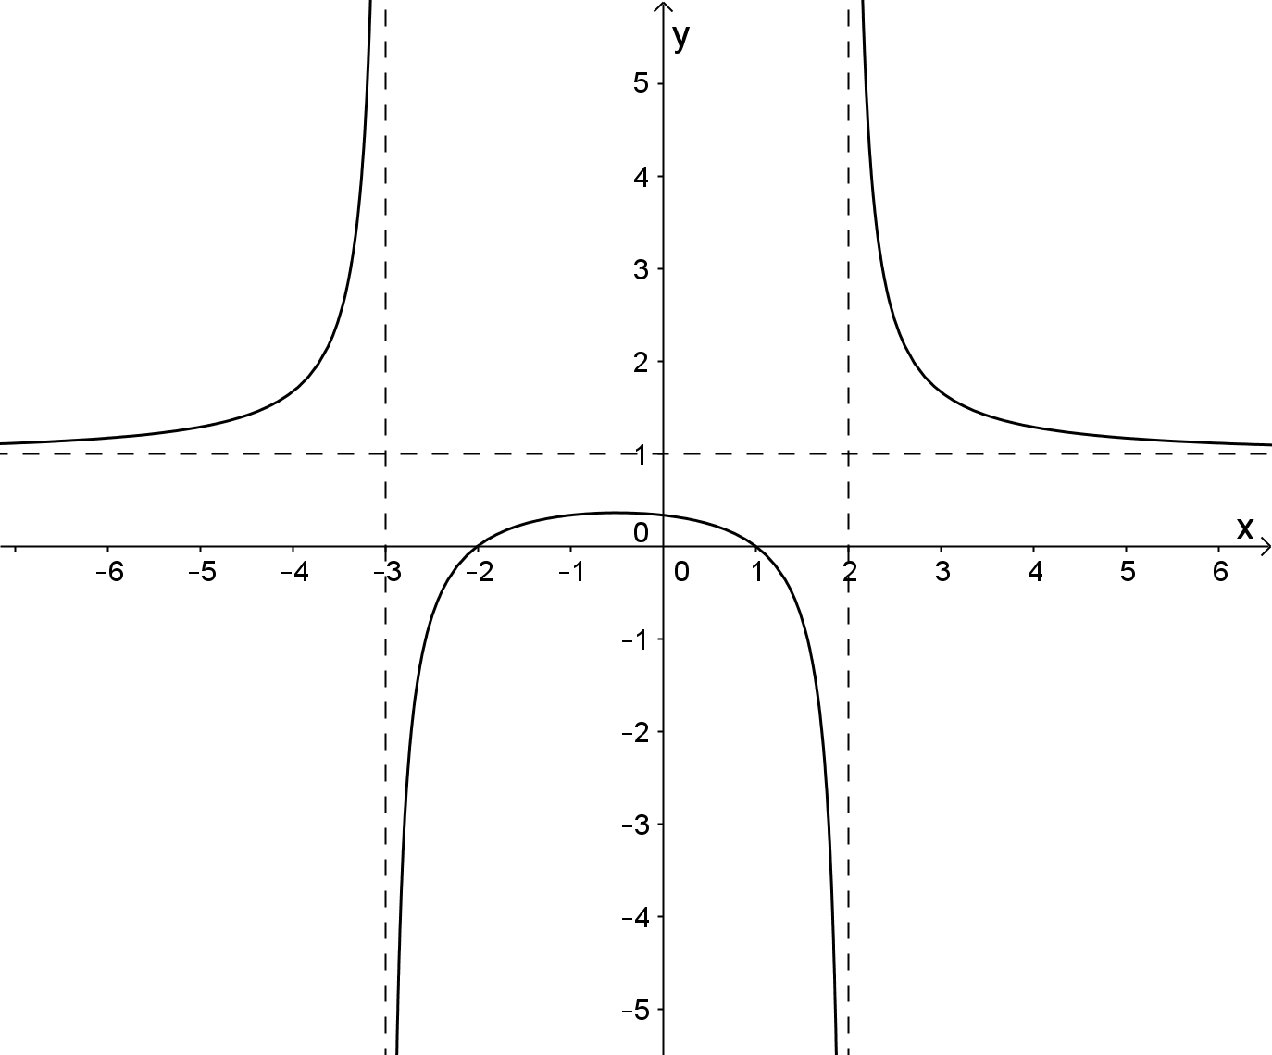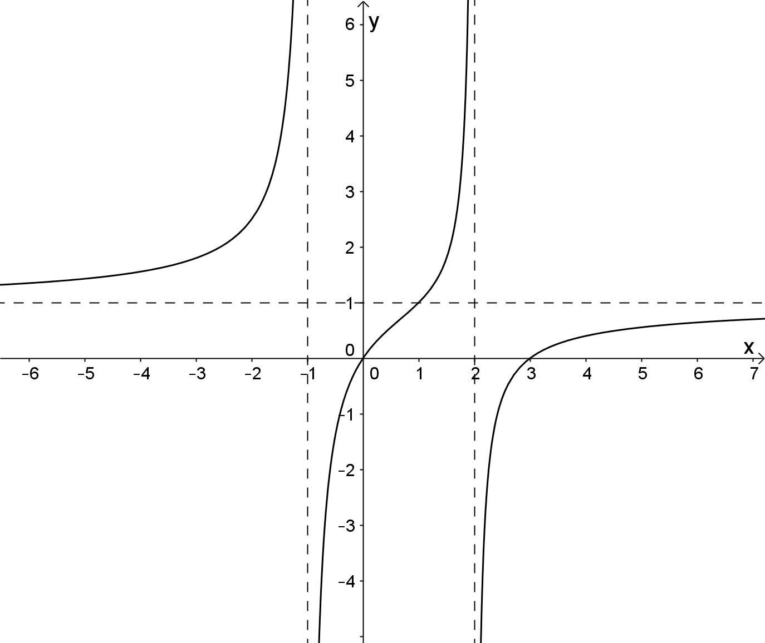
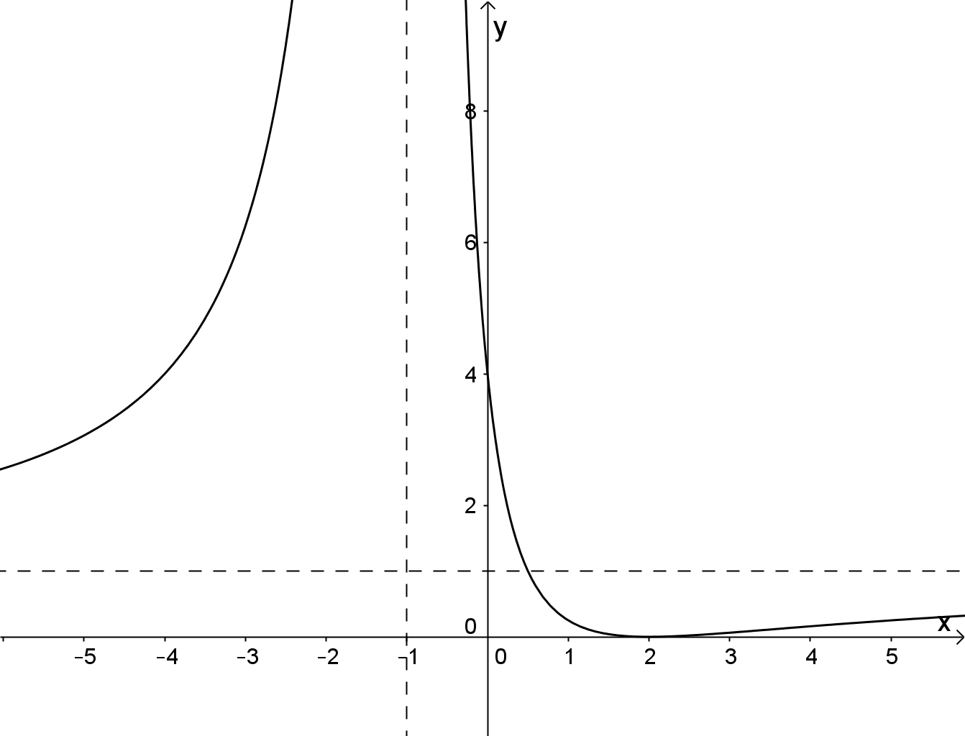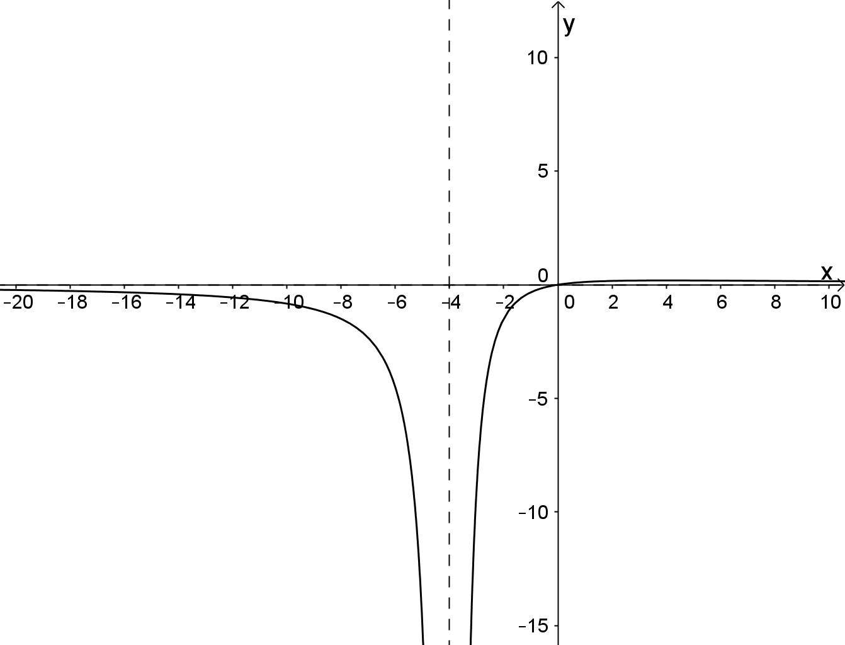

(b)
Solution
where has no real roots.
For example,
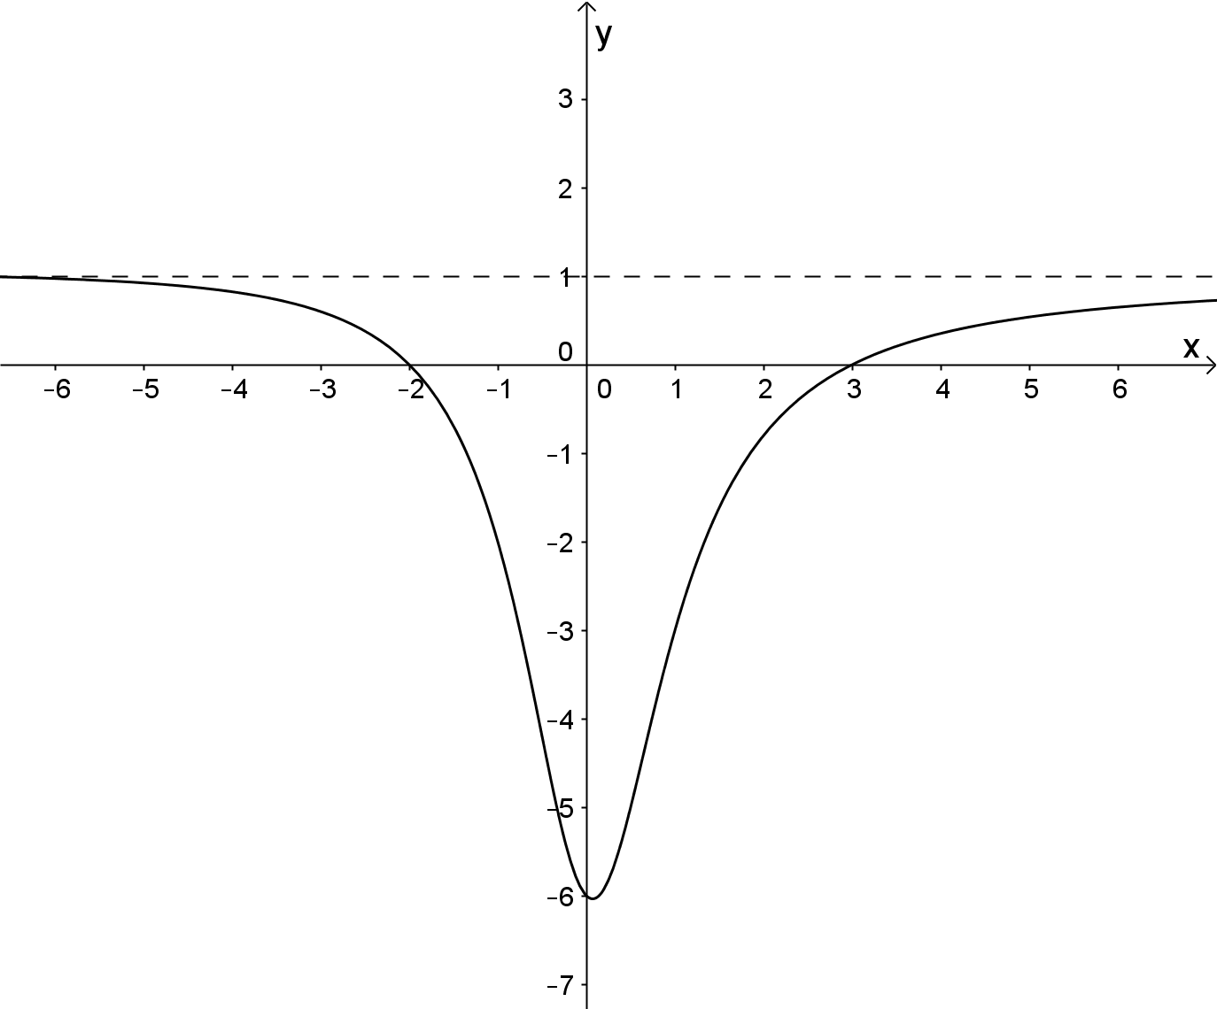
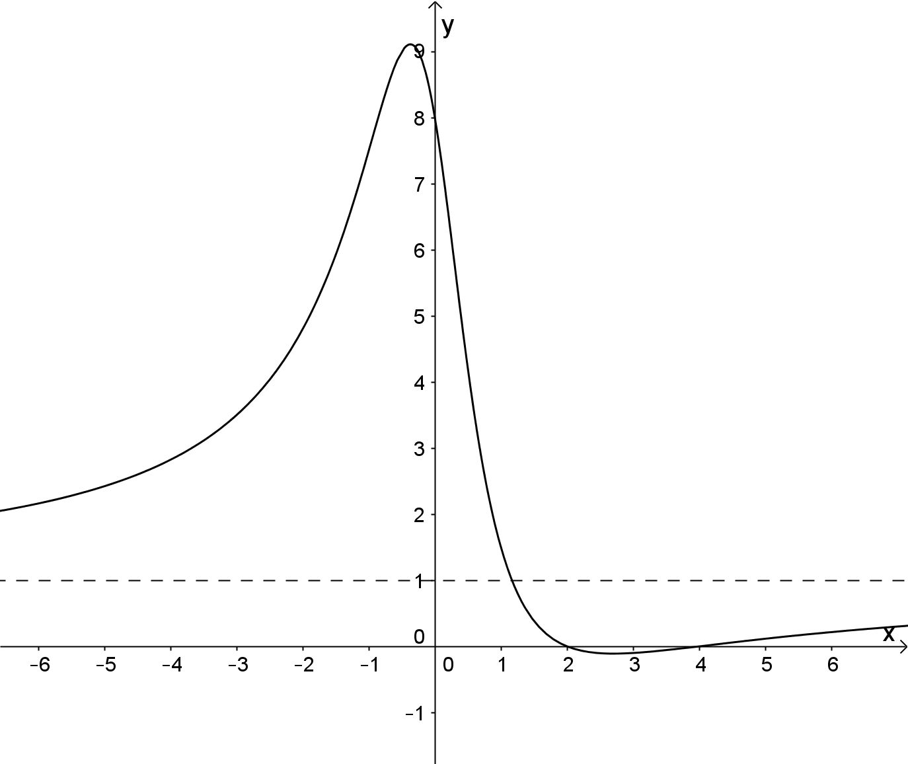

(c)
Solution
where has no real roots.
For example,
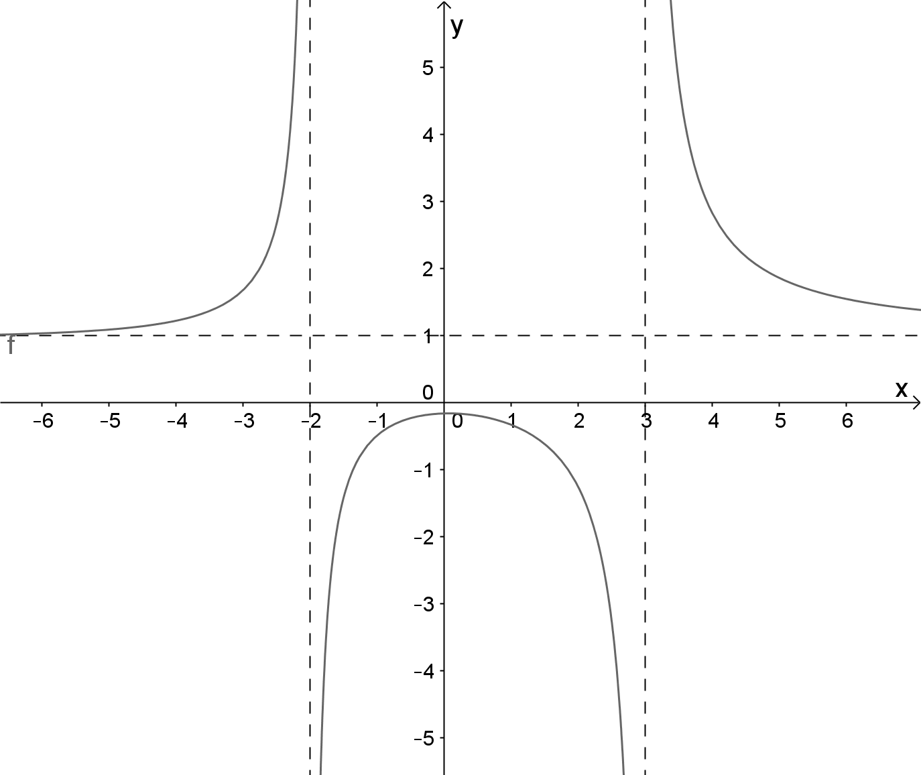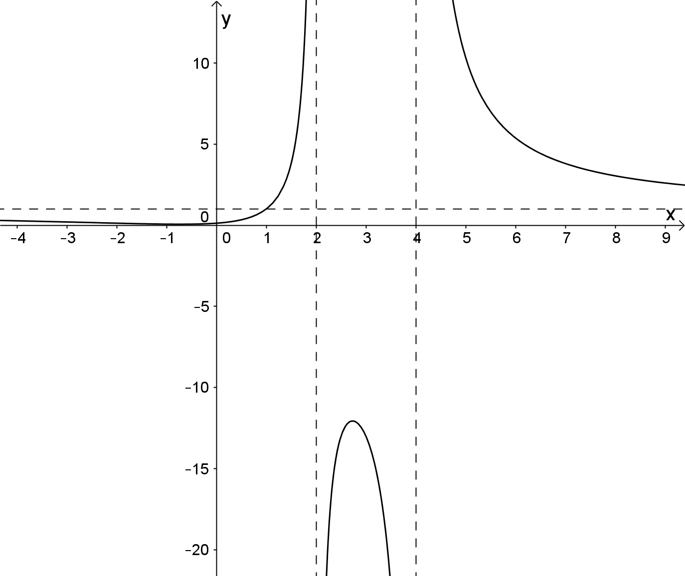

(d)
Solution
where neither nor have real roots.
For example,
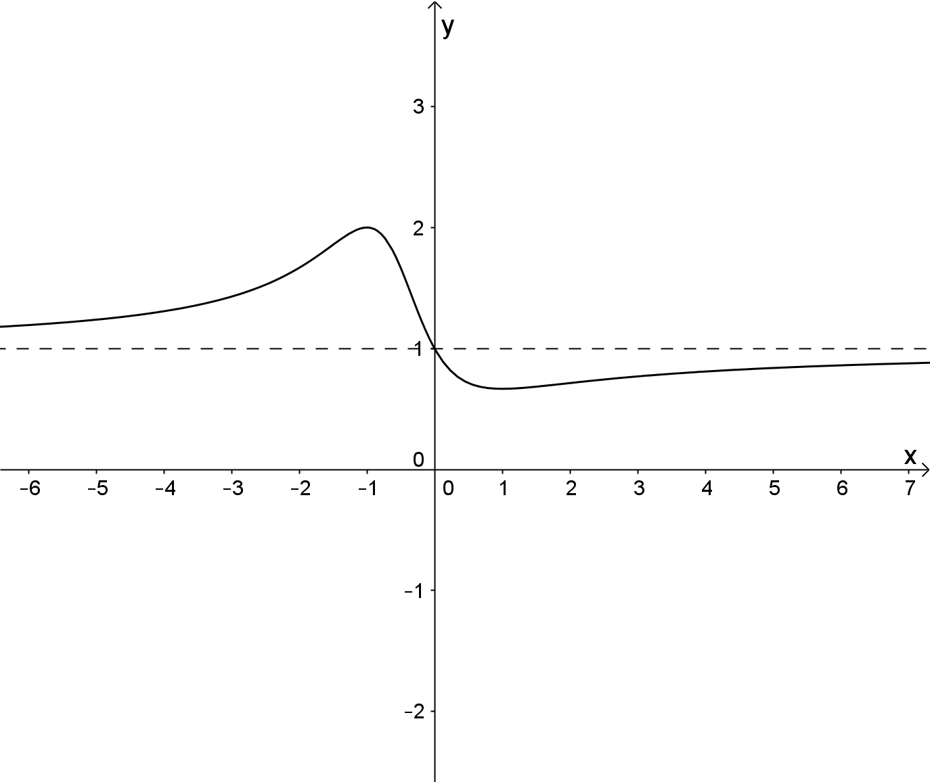

(e)
Solution
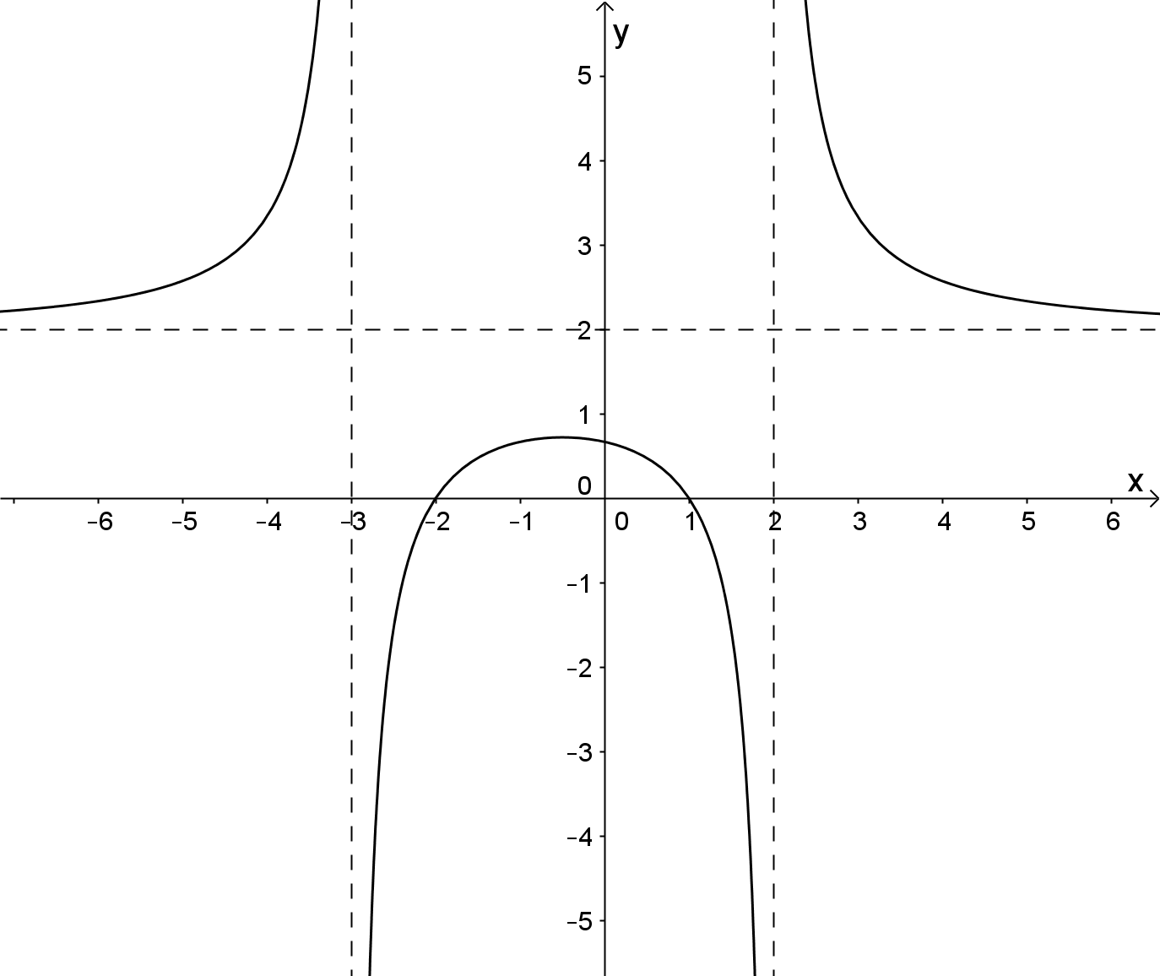
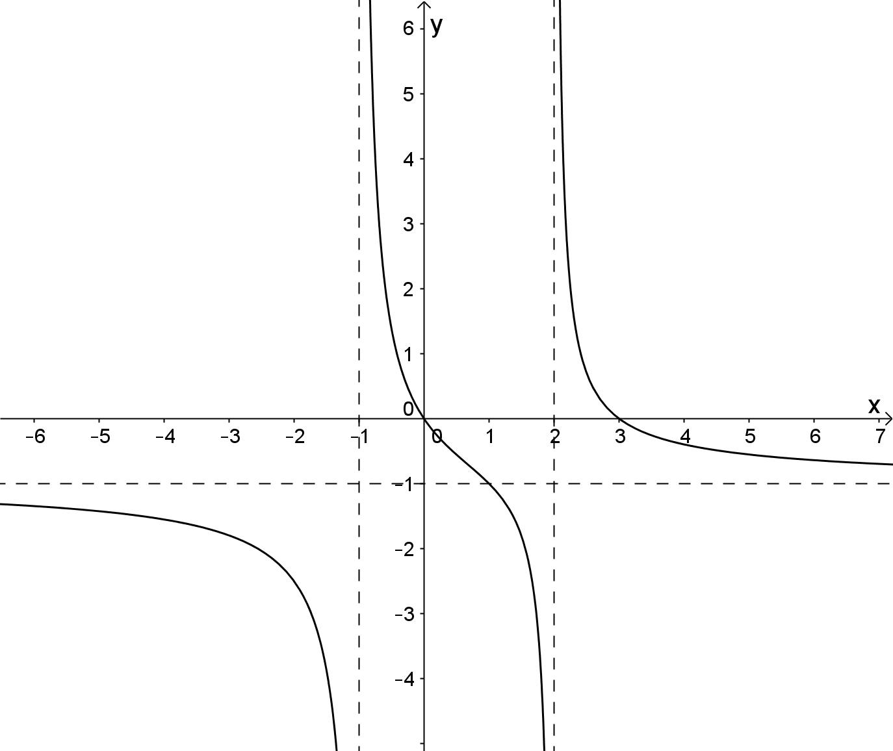
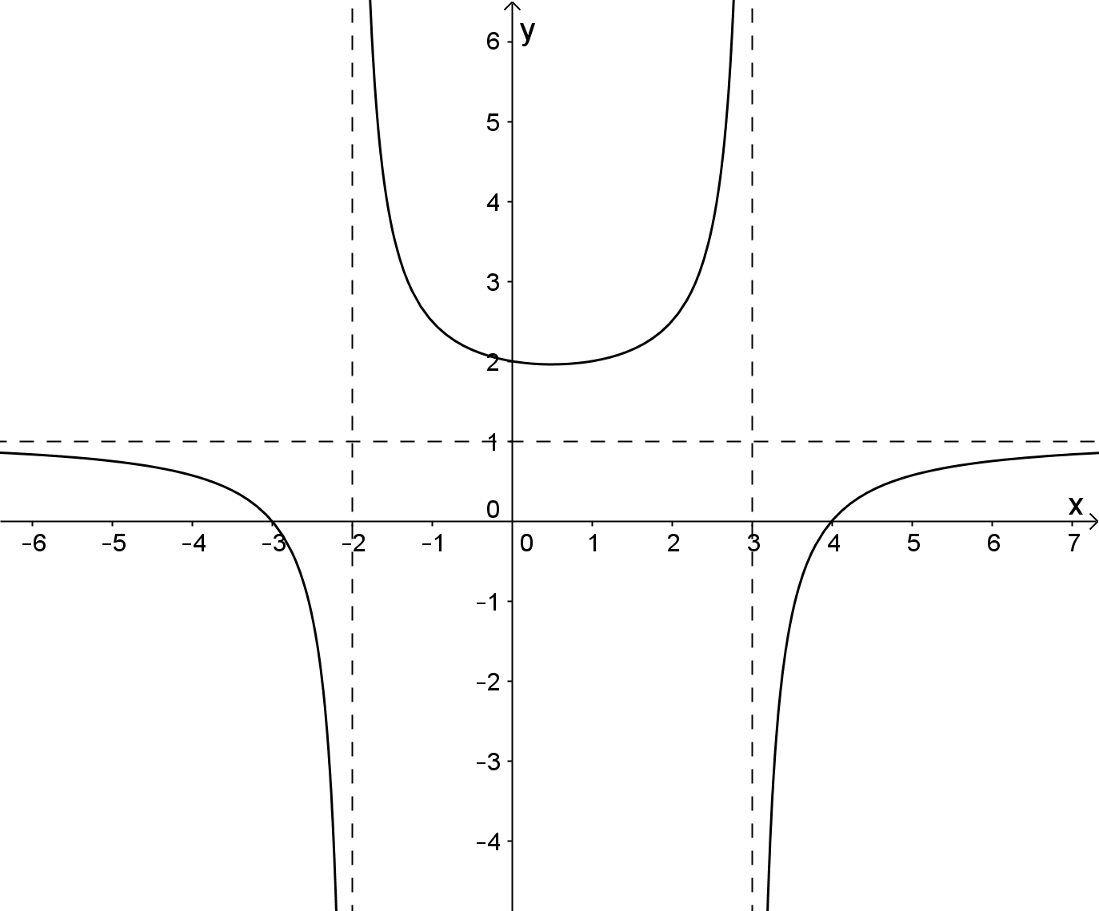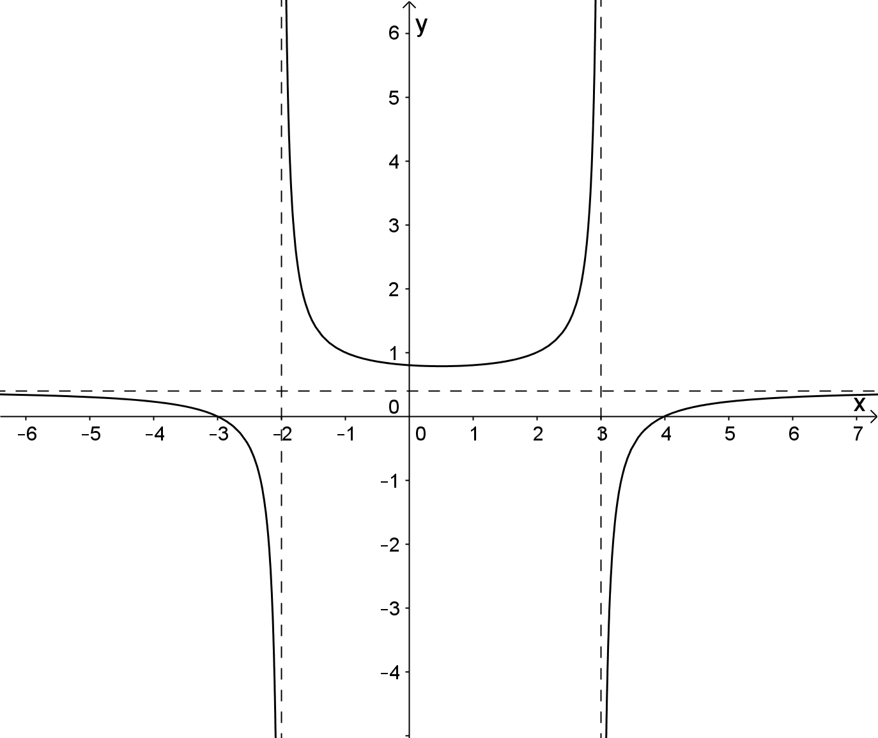

THE GRAPHS OF RATIONAL FUNCTIONS

Extended investigation Part 2: In-class validation
Solutions and marking key

Question 1
Solution
(a) Vertical asymptotes occur where
The equation of the vertical asymptote is .

(b) Horizontal intercepts:
Vertical intercept:
(c)

As , hence the horizontal asymptote has equation .
As .
As
(d)
Graph intersects horizontal asymptote at .

(e)
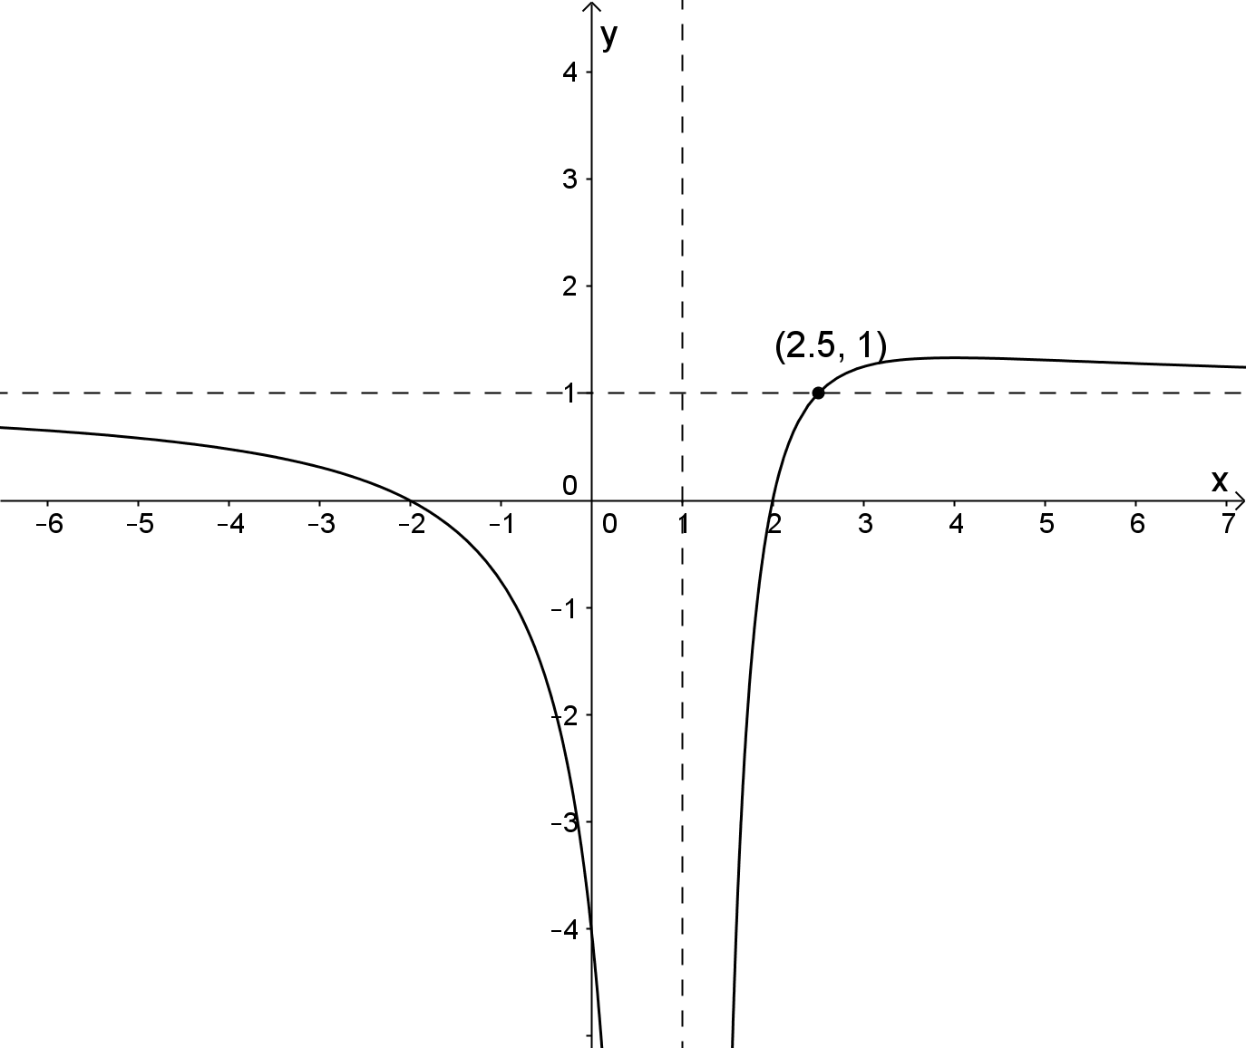

Mathematical behaviours | Marks
- (a) Determines vertical asymptote  - (b) Determines horizontal and vertical intercepts  - (c) Considers the behaviour of the graph as  - Determines the horizontal asymptote  - (d) Determines coordinates of point of intersection  - (e) Correctly sketches the function showing asymptotes, intercepts and point of intersection of graph and horizontal asymptote | 1  2  1  1  2  3

Question 2
Solution
No vertical asymptotes since .
Vertical intercept: .
As , hence the horizontal asymptote has equation .
No horizontal intercepts since .
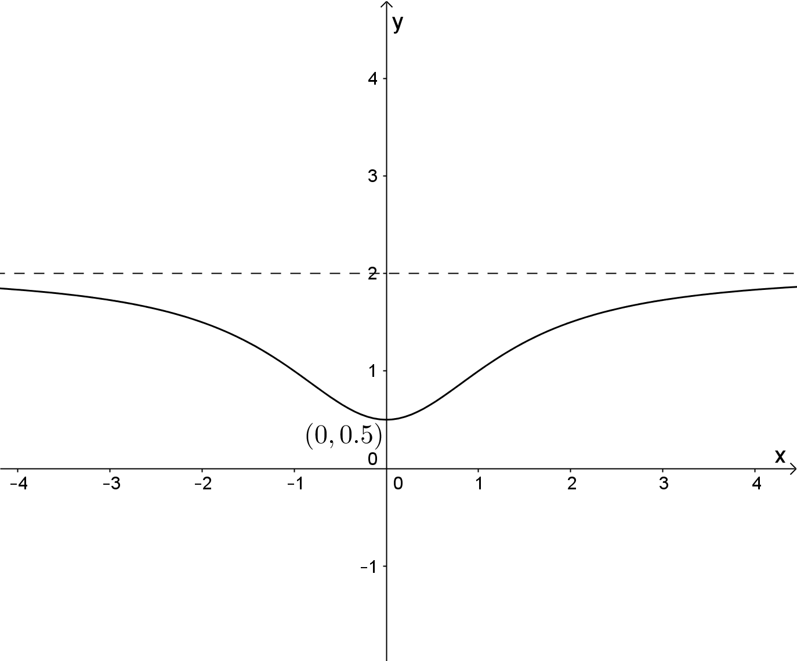

Mathematical behaviours | Marks
- Concludes no vertical asymptote  - Determines vertical intercept  - Considers the behaviour of the graph as  - Determines the horizontal asymptote  - Correctly sketches the function showing asymptote and intercept | 1  1  1  1  2

Question 3(a)
Solution
Mathematical behaviours | Marks
- Expresses numerator in terms of denominator  - Correct proper fraction  - Correct | 1  1  1

Question 3(b)
Solution
As ,
Mathematical behaviours | Marks
- Determines behaviour of as | 1

Question 3(c)
Solution
As ,
is the equation of the oblique asymptote.
Mathematical behaviours | Marks
- Determines behaviour of as  - States equation of the oblique asymptote. | 1  1

Question 4
Solution

Vertical asymptote has equation .
As ,
is the equation of the oblique asymptote.

Horizontal intercepts:
Vertical intercept:

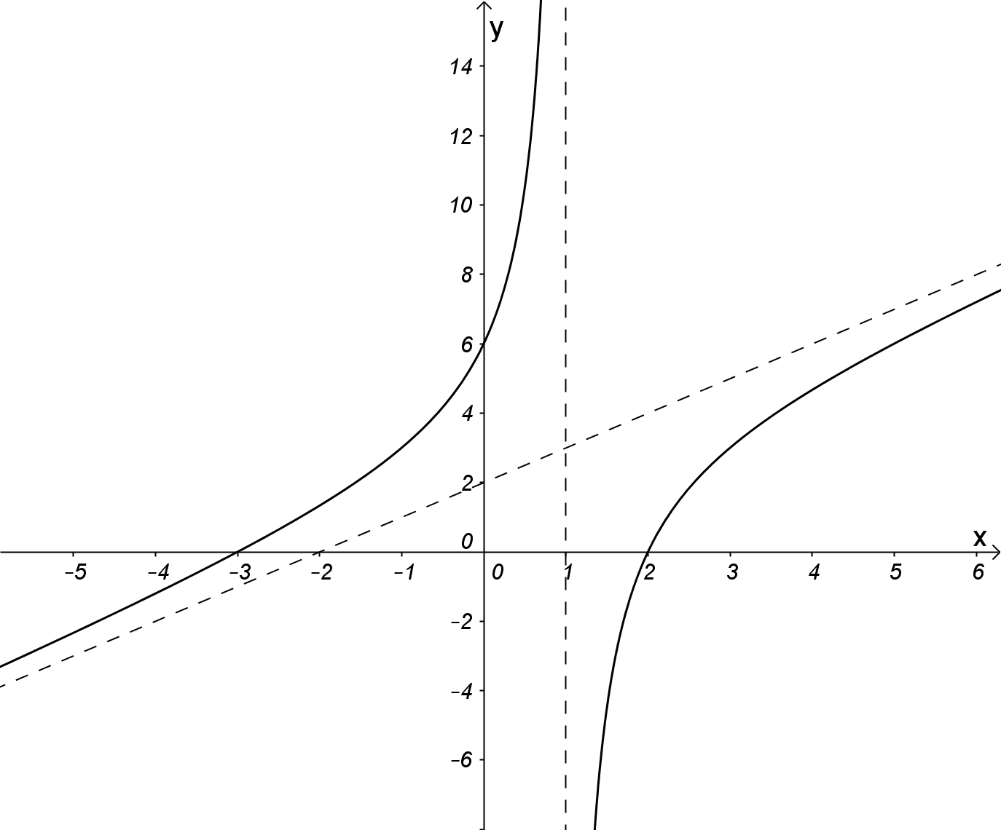
Mathematical behaviours | Marks
- Determines equation of vertical asymptote  - Expresses in the form of  - Determines behaviour of as  - States equation of the oblique asymptote  - Determines horizontal intercepts  - Determines vertical intercept  - Correctly sketches the function showing asymptotes and intercepts | 1  1  1  1  1  1  3

Question 5(a)
Solution
Equation of oblique asymptote is .
Mathematical behaviours | Marks
- Correct equation | 1

Question 5(b)
Solution
Vertical asymptotes have equations , hence .

Horizontal intercepts are , hence
Vertical intercept is , hence
Giving,
Thus .
Mathematical behaviours | Marks
- Identifies vertical asymptotes  - Determines  - Identifies horizontal intercepts  - Determines factors in numerator  - Identifies vertical intercept  - Determines  - Expands numerator  - Determines | 1  1  1  1  1  1  1  1

TASK 5

THE ABSOLUTE VALUE FUNCTION

In-class investigation

Unit 3

Topic 3.2: Functions and sketching graphs

Course-related information

The concepts and skills included in this investigation relate to the following dot points within the WA Mathematics Specialist syllabus.
3.2.6 use and apply for the absolute value of the real number and the graph of
3.2.7 examine the relationship between the graph of

The ability to choose and use appropriate technology to enhance and extend concept development are also incorporated within some of the items.

Background information

It is assumed students have successfully completed Methods 1.1.15 (Powers and polynomials), Methods 1.2.9 – 1.2.12 (Trigonometric functions) and Specialist 3.2.1 – 3.2.5 (Functions)

Task conditions

For this task students should complete questions 1 and 2 without access to calculators. Students should complete questions 3 and 4 using calculators. No student notes are required.

The absolute value function

In-class investigation (Total marks: 48)

The absolute value function, is defined as .
Hence, |-3| = 3, |4.2| = 4.2, and |0| = 0.

The graph of is shown below
The graph of are shown below

Question 1 (7 marks)

(a) Use the definition of to define
(i)

(ii) (2)

(b) Hence define (3)

(c) Sketch (2)

Question 2 (14 marks)

Given the functions .
(a) On separate axes, sketch and label each of the functions (2)

(b) (i) Sketch

(ii) Sketch and compare your graph to the graph in (i).

(iii) Sketch

(iv) Let . Find a domain for such that exists. (7)

(c) (i) Give the domain and range of and .

(ii) Sketch . (5)

Question 3 (14 marks)

Investigate the graphs of for
(a) (7)

(b) (7)

Question 4 (13 marks)

(a) Investigate the solutions to for
(i) (4)

(ii) (5)

(b) Investigate the number of solutions for the equation . (4)

The absolute value function

In-class investigation
Solutions and marking key

Question 1
Solution
(a) (i)
(ii)
(b)
(c)

Mathematical behaviours | Marks
- correctly defines  - correctly defines  - chooses the correct sub-domains for  - correctly defines on each subdomain  - produces an accurate sketch on each subdomain | 1  1  1  2  2

Question 2(a)
Solution
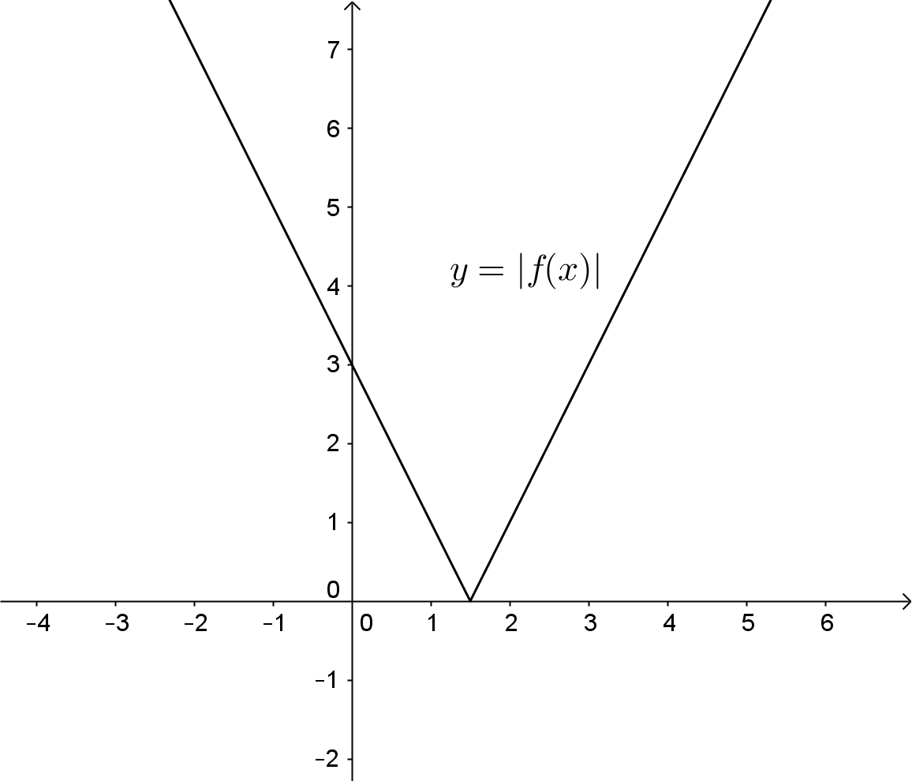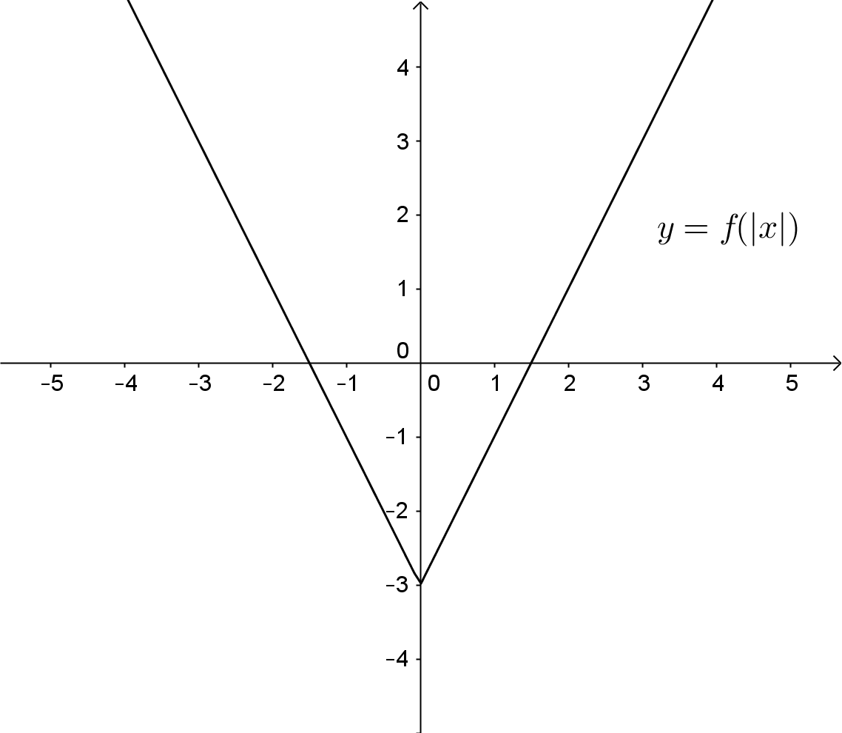
Mathematical behaviours | Marks
- Correctly graphs  - Correctly graphs | 1  1

Question 2(b)
Solution
(i) (ii)
They are effectively the same graph.

(iii)
(iv) only exists if is a one-to-one function. Restrict the domain of to .
Other domains may be used.

Mathematical behaviours | Marks
- (i) Correctly graphs on the given domain  - (ii) Correctly graphs on the given domain  - concludes graphs are the same  - (iii) Correctly graphs  - (iv) States a domain such that exists | 2  2  1  1  1

Question 2(c)(i)
Solution
Mathematical behaviours | Marks
- Correct domain for  - Correct range for  - Correct domain for  - Correct range for | 1  1  1  1

Question 2(c)(ii)
Solution
Mathematical behaviours | Marks
- Correctly graphs | 1

Question 3(a)
Solution
for
Student uses calculator to draw a number of graphs satisfying and concludes:
the graph comprises three line segments of the form,
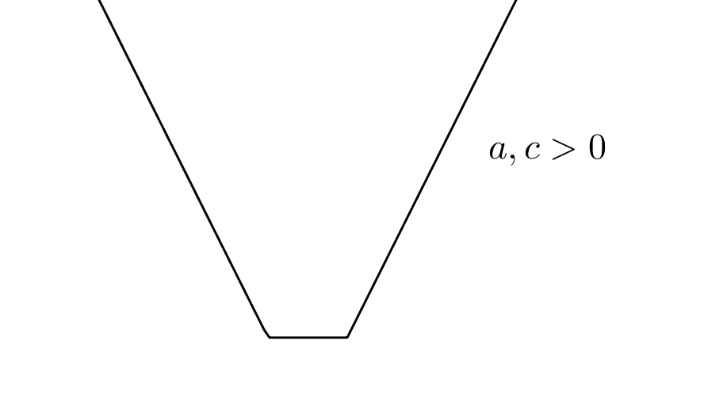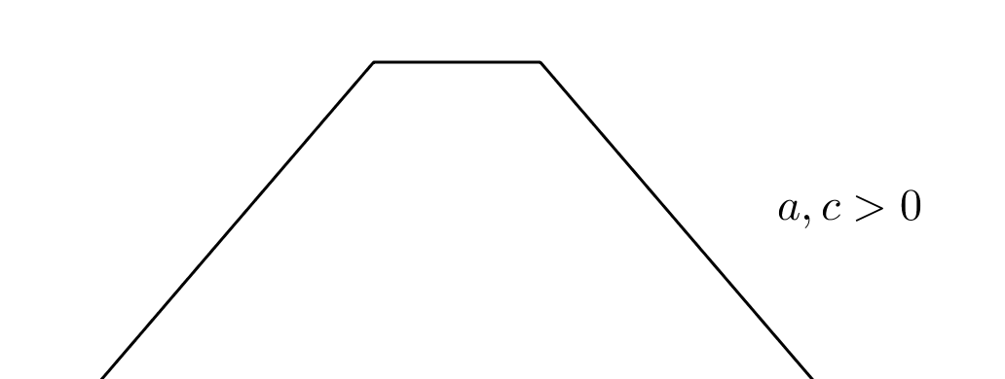
the central line segment has a gradient of zero,
the two outer line segments have opposite gradients.
Mathematical behaviours | Marks
- draws at least three graphs  - correct conclusion for shape if  - correct conclusion for shape if  - concludes central line segment has zero gradient  - concludes outer line segments have opposite gradients | 3  1  1  1  1

Question 3(b)
Solution
for
Student uses calculator to draw a number of graphs satisfying and concludes:
the graph comprises three line segments,
each line segment has a different gradient,
no line segment has a gradient of zero,
the two outer line segments have opposite gradients.
Mathematical behaviours | Marks
- draws at least three graphs  - correct conclusion for shape if  - concludes three different gradients  - concludes no gradient is zero  - concludes outer line segments have opposite gradients | 3  1  1  1  1

Question 4(a) (i)
Solution
for
Student uses calculator to draw a number of graphs satisfying and concludes that the graphs intersect once; hence the equation has one solution.
Mathematical behaviours | Marks
- draws at least 3 graphs  - concludes equation has one solution | 3  1

Question 4(a) (ii)
Solution
for
Student uses calculator to draw a number of graphs satisfying and either both positive or both negative and concludes that the graphs intersect twice; hence the equation has two solutions.

Student uses calculator to draw a number of graphs satisfying and have opposite signs and concludes that the graphs do not intersect; hence the equation has no solutions.
Mathematical behaviours | Marks
- draws at least 3 graphs  - concludes equation has two solutions if and have the same sign  - concludes equation has no solutions and have opposite signs | 3  1  1

Question 4(b)
Solution
There are three situations to consider:

Mathematical behaviours | Marks
- Determines that three situations need to be considered  - Concludes two solutions if  - Concludes one solution if  - Concludes no solutions if | 1  1  1  1

TASK 6

INVESTIGATIVE QUESTIONS

Unit 3

Topic 3.2: Functions and Sketching graphs

Course-related information

The concepts and skills included in these investigative questions relate to:
3.2.1 determine when the composition of two functions is defined
3.2.2 determine the composition of two functions
3.2.3 determine if a function is one-to-one
3.2.4 find the inverse function of a one-to-one function
3.2.5 examine the reflection property of the graphs of a function and its inverse
3.2.7 examine the relationship between the graph of
3.2.8 sketch the graphs of simple rational functions where the numerator and denominator are polynomials of low degree

Background information

The ability to choose and use appropriate technology to enhance and extend concept development are also incorporated within some of the items.

In question 1 it is assumed that students have successfully completed Methods 2.3 (Introduction to differential calculus), Methods 3.1 (Further differentiation and applications), and Specialist 3.2.1 – 3.2.5 (Functions)

In question 3 it is assumed that students have successfully completed Methods 1.2.9 – 1.2.12, 3.1.5, 3.1.9 (Trigonometric functions and Differentiation rules), 3.2.1 – 3.2.2 (Anti-differentiation), Specialist 2.1.5 (Pythagorean identities) and Specialist 3.2.3 – 3.2.5 (Functions)

Task conditions

These questions are independent of each other and are written so that they may be incorporated into a test or examination. The time required to complete each question is left to the discretion of the teacher but the intention is that each question may be completed within 15 minutes.
Investigative questions for Topic 3.2

Question 1 (10 marks)
Use the functions and to determine whether:
(a) (3)

(b) (5)

(c) (2)

Alternative Question 1

Question 1 (10 marks)
Use the functions and to determine whether:
(a) (3)

(b) (5)

(c) (2)

Question 2 (11 marks)

Determine the equation of the rational functions whose graphs are shown below.
(a) and (5)

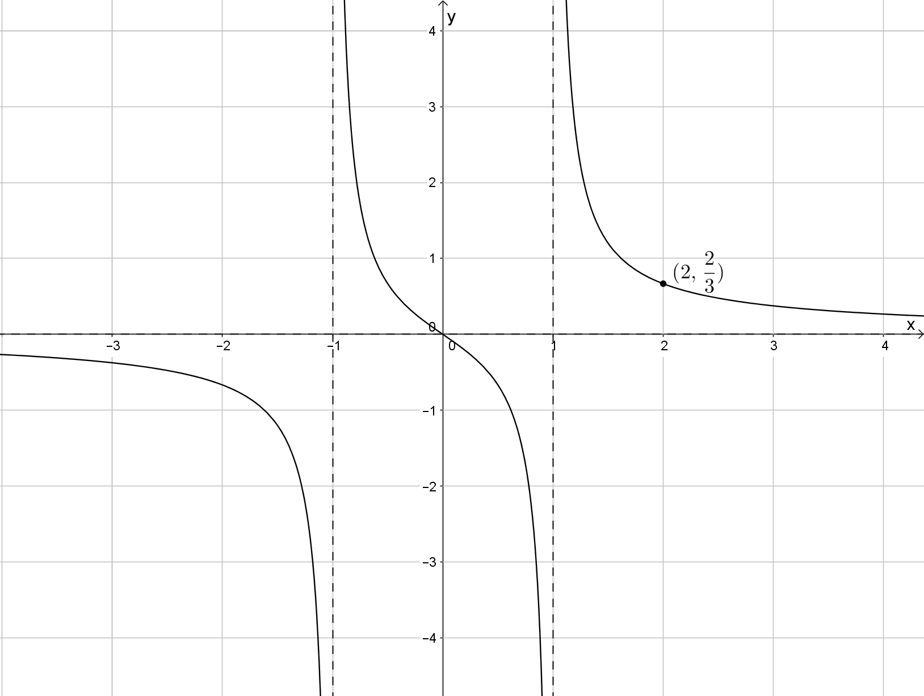

(b) and (6)

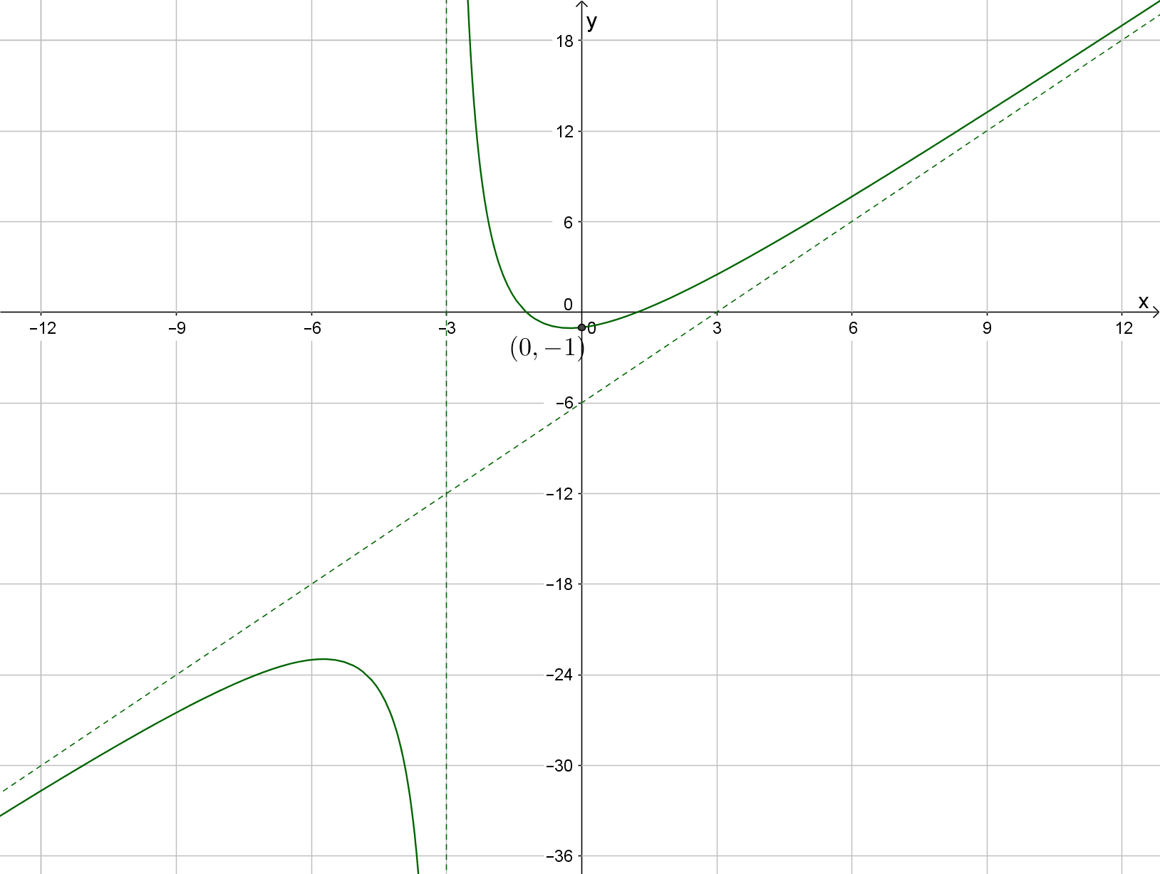

Question 3 (11 marks)

Given the function , then
To determine ,
let

Determine
(a) (3)

(b) (3)

(c) (2)

(d) by letting (3)

Investigative questions for Topic 3.2
Solutions and marking key

Question 1(a)
Solution
and
∴
Mathematical behaviours | Marks
- correctly determines  - correctly determines  - concludes that | 1  1  1

Question 1(b)
Solution
and

∴
Mathematical behaviours | Marks
- correctly determines  - correctly determines  - correctly determines  - correctly determines  - concludes that | 1  1  1  1  1

Question 1(c)
Solution
and

∴
Mathematical behaviours | Marks
- correctly determines  - concludes that | 1  1

Alternative Question 1
Question 1(a)
Solution
and
∴
Mathematical behaviours | Marks
- correctly determines  - correctly determines  - concludes that | 1  1  1

Question 1(b)
Solution
and

∴
Mathematical behaviours | Marks
- correctly determines  - correctly determines  - correctly determines  - correctly determines  - concludes that | 1  1  1  1  1

Question 1(c)
Solution
and
∴
Mathematical behaviours | Marks
- correctly determines  - concludes that | 1  1
Question 2(a)
Solution
and are vertical asymptotes
Graph passes through .
is a point on the graph
Equation of rational function is
Mathematical behaviours | Marks
- identifies the two vertical asymptotes  - concludes  - concludes  - determines  - writes equation of rational function | 1  1  1  1  1

Question 2(b)
Solution
is a vertical asymptote
is a point on the graph
Equation of oblique asymptote is .

Mathematical behaviours | Marks
- identifies the vertical asymptote  - concludes  - concludes  - determines equation of oblique asymptote  - determines  - writes equation of rational function | 1  1  1  1  1  1

Question 3(a)
Solution
let
Mathematical behaviours | Marks
- determines the derivative of  - determines an expression for in terms of  - determines an expression for in terms of | 1  1  1

Question 3(b)
Solution
let

Mathematical behaviours | Marks
- determines the derivative of  - determines an expression for in terms of  - determines an expression for in terms of | 1  1  1
Question 3(c)
Solution
let
Mathematical behaviours | Marks
- Applies the chain rule  - determines an expression for in terms of | 1  1

Question 3(d)
Solution
Let
Mathematical behaviours | Marks
- Rewrites the integral using the substitution  - Writes the anti-derivative in terms of  - Writes the anti-derivative in terms of | 1  1  1

